**datacommunicationsbasics(past)**

**Data Communications Basics**

**A Data Communication Historical Series**

**By Bob Pollard**

**A basic overview of the development of Telegraphy and Data Communication:**

A little basic electronic theory and some of the basic associated functions that make Data Communications possible are presented as they occurred over the years through the 1960s. The theory of operation or function would still apply today, but the speed of operation would be much greater.

**Electricity / Electronics:**

In the 1950s a description of electricity might have been presented as follows: The elementary particles of electricity are the electron and the proton, which are electrically opposite (different polarity). There can be negative (-) electricity or a negative charge when the primary element is the electron or positive electricity (+) or positive charge when the primary element is the proton. Electrical flow or electron flow is generally viewed as flowing from negative to positive when normal household or other electronic devices are being discussed. This is also true for Data Communication functions. Internal design and construction of individual devices may involve the use of negative or positive polarities for current flow in order for the device to function properly.

Prior to 1940 all electronic design was based on the theory that current flowed form positive to negative.

Today a description of electricity would include descriptions of atoms, nucleus, electrons and how they function together to produce electricity, as illustrated below.

[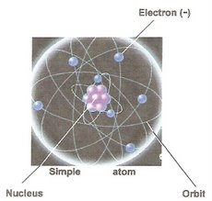](https://sites.google.com/site/mdprcp/Basics-1.jpg?attredirects=0)

In materials, such as Wood, glass, plastic, ceramic, and air the electrons are tightly bound to the atoms. The electrons stick with their atoms. Because the electrons do not move these materials are not good electrical conductors and would be considered electrical insulators.

Most metals have electrons that can detach from their atoms and move around and these would be referred to as free electrons. For example: gold, silver, copper, aluminum and iron all have free electrons, which makes it easy for electricity to flow through these materials. Therefore, these materials would be referred to as electrical conductors. They conduct electricity, which allows the moving electrons to transmit electrical energy from one point to another.

This electron flow moves at, approximately, the speed of light; 186,000 miles per second. The actual speed of information through an electronic circuit is determined by the type of conducting material and circuit components, which can slow down the flow of electrons or cause delays within equipment functions.

**Electron or Current Flow:**

When discussing or describing electrical circuits or components, or the movement of electrons (current flow), the terms ‘Direct Current’ or Alternating Current is normally used. These may also be referred to as just DC or AC or DC voltage (Volts) or AC voltage (Volts). Current flow is measured using the unit Ampere (Amp). The unit Ampere can be broken down into smaller increments using the unit of measurement, such as: milliamps (1 thousand of an Amp) Watt(s) (Wattage) or Kilowatt (1 thousand Watts).

Every device will normally have a tag attached to the device that states the required voltage (DC or AC) and the operating amperage (amp). The operating amperage may be stated in a number of amps or a specified operational wattage (watts) may be used.

Examples:

• An electric motor might have an attached tag that states 120 volts AC; 10 amps. This indicates the motor must be connected to a 120-volt AC circuit and the motor will draw 10 amps when running under normal conditions.

• A micro-wave oven might have a tag that states 120 volts AC; 700 watts. This implies the micro-wave requires a 120-volt AC connection and will draw 700 watts on the circuit.

The terms amps or watts are used to designate an existing designed current flow value or to designate a design value required to operate the unit or device being manufactured. High power requirement circuits or devices will usually use the amp designation. Low power devices will normally use a watt designation.

The watts or amps measurement can be converted from one to the other through a simple mathematic formula. For instance, an electric motor operating at 10 amps or 1200 watts; 120 volts x 10 amps = 1200 watts. The micro-wave operates at 700 watts or 5.8 amps; 700 watts / 120 volts = 5.8 amps. As indicated in these calculations to convert amps to watts simply multiply the amps by the voltage. To convert watts to amps, divide the total watts by the voltage. The term ‘milliamps’ may also be used for various applications; 1 milliamp = 1000th of an Amp.

Current flow (electron flow) is created by the pressure applied to the circuit and the voltage is the pressure. A good example of this process is water flowing through a pipe. In the example below when the valve is turned on the water under pressure will flow through the pipe and come out the end of the pipe. The water pressure is created by a pump or a storage facility, like a water tank or pond that creates pressure because of the weight of the water.

[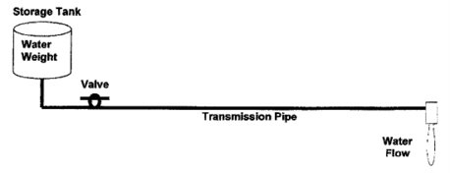](https://sites.google.com/site/mdprcp/Basics3-1.tif?attredirects=0)

But, Instead of using a hollow pipe, such as used for water, electron flow uses a solid conductor, excluding radio signals, which are transmitted into the atmosphere. This conductor can use many different types of material and as stated earlier some are better conductors than others.

Also, unlike the water pipe, which is empty until the valve is turned on; electrons exist along the entire length of an electrical conductor. This conductor can be a wire (circuit) from end to end (negative to positive battery connection) or a wire that connects to a common ground on one end. A ground can be a metal plate or the chassis of a device where all the circuits terminate. Figure 3-2 provides an example of a connection between the negative battery terminal, through a device, and the positive battery terminal; no ground is involved. Figure 3-2A illustrates a connection between the battery negative terminal, through the device, and a ground.

The positive battery terminal is also terminated through a ground, which provides a complete circuit path through the common ground. Normally, such as the electrical connections in a car, the negative battery terminal is grounded to the chassis and the connections to the positive battery terminal route through all the electrical components. It might be noted that many years ago some of the car manufactures grounded the positive battery terminal and routed the negative battery terminal connections to all the electrical components.

[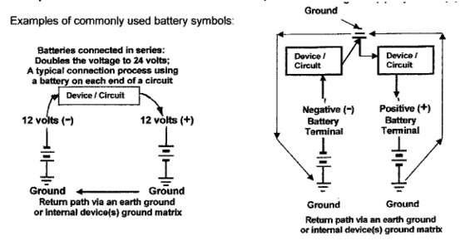](https://sites.google.com/site/mdprcp/Basics-3-2.tif?attredirects=0)

Electron flow within a circuit is energized (created) through the application of a battery (voltage) source. The flow of electrons within the entire circuit length begins simultaneously; between voltage source (negative)and voltage source (positive). Many circuits can be active simultaneously through a common ground. Also the voltage source could be a generator instead of a battery. The battery source and the ground termination, with a device in between, could be hundreds of miles apart without signal regeneration (renewal) under good conditions. The circuit illustrated above left with batteries on both ends of the circuit in series allows longer circuits to be utilized.

**Direct Current (DC):**

In the early days, prior to the late 1930s, with the exception of DC (Direct Current) simplex circuits that were used for telegraphing on a pair of shared telephone lines in the late 1800s, all data (message) communications used DC for the power source, both locally for the sending and receiving devices and on a single connecting line (circuit). A pulse pattern (bits) in series was generated for each character sent, which was deciphered by the receiving device. These pulses are basically generated in the same manner as turning a switch on and off. Refer to Figures 3-2, Figure 3-2A and 3-3. In the Morse code system, the ‘key’ device functioned like a single switch where a keyboard and the associated transmitting device use a multiple switch matrix. Different data transmission code sets that are covered in the Code sets Chapter produced different numbers of bits (pulses) for each character. The switch in Figure 3-2 and Figure 3-2A represents a sending device and the bulb symbol represents a receiving device.

[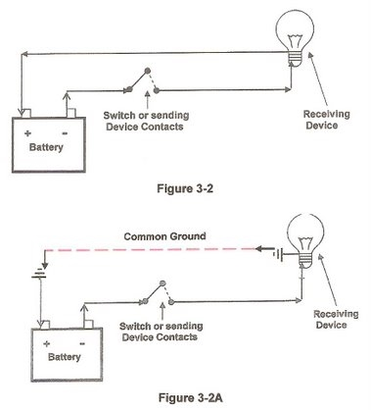](https://sites.google.com/site/mdprcp/Basic-3-23-2A.jpg?attredirects=0)

The battery provides the DC (voltage / pressure) when the switch is closed; opening the switch will remove the DC (voltage / pressure). Opening and closing the single switch will produce a current flow (switch closed) or no current flow (switch open) as shown in Figure 3-3, which could represent any receiving device.

[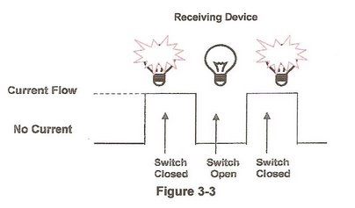](https://sites.google.com/site/mdprcp/Basic-3-3.jpg?attredirects=0)

This bit pattern caused by opening and closing a switch(s) can be used to send information / alphanumeric characters on a line connecting two or more devices. It’s a matter of forming different bit patterns to represent different characters or other information. A few examples of bit patterns that represent characters are presented in later illustrations.

Most of the early code sets (1800s) used dots and dashes to identify the different characters; the dot is a short current level on the line and the dash is a longer current level on the line, with a pause (0 current) between characters. One of the first American telegraphy devices was the Edison key (left) and receiver (right) shown below.

[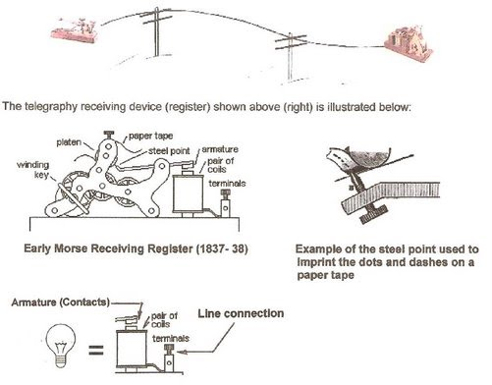](https://sites.google.com/site/mdprcp/EarlyTel.jpg?attredirects=0)

The coils on the register are energized by the current on the line that is connected to the relay terminals. When the coil is energized by current flow on the line it closes the armature contacts. The closing contacts cause the steel pointer to emboss (mark) the tape, which in turn provides a representation of the received dots and dashes on the moving tape. The tape was usually driven by a simple clock works.

Basically, the relay takes the place of the light bulb in this discussion; as presented in previous illustrations. The bit pattern would energize the relay. Shown below is an example of the dot and dash code set used by the Edison telegraphy system; the illustrated dot and dash patterns represent the word ‘NOW’; the dots and dashes were embossed on the moving tape in the order of reception.

[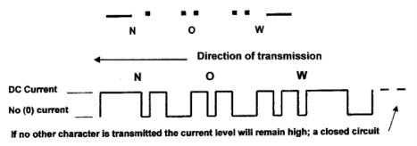](https://sites.google.com/site/mdprcp/morse-now.tif?attredirects=0)

This closing and opening the line (circuit) is what occurs when a key is depressed on a keyboard of a sending device. A stream (series) of pulses (bits) is generated with each keystroke, which in turn, with a simple DC circuit, will appear on the connecting line and then will be received at the receiving device. Using the Baudot Code, the letter ‘A’ can be illustrated as shown in Figure 3-4, which represents what is called ‘make’ – ‘break’ or ‘mark’ – ‘space’ signals. The terms make and mark represent the 1 bit (current flow) and the terms break and space represents the 0 bit (no current flow).

[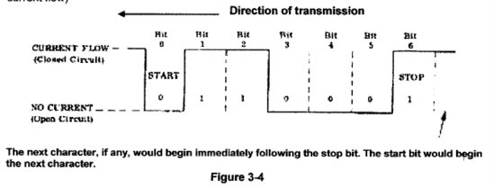](https://sites.google.com/site/mdprcp/Figure3-4.tif?attredirects=0)

Teletypewriter code sets normally use bit patterns where each bit was of equal length with the exception of the stop bit is some cases. Some devices required a longer stop bit and the stop bit could be 1.42 or 1.5 the length of the other bits. Figure 3-4 shows the Baudot code letter ‘A’ bit pattern. The stop bit in this example is the same length as the other bits.

The bits are transmitted in the following order: start; 1 thru 5; stop. The ‘start’ and ‘stop’ bits are used for ‘asynchronous’ operation, which implies that each generated character requires a start and stop synchronizing function (bit) to be attached by the send device (transmitter). These start and stop bits allow the receiving device to stay synchronized with the sending device because the start and stop bits identify each individual character. When the sending and receiving device are directly connected, assuming no intermediate device that allows for buffering or code conversion, the sending and receiving devices must operate at the same speed therefore both devices must function at the same bit per second (bps) or characters per minute rate, and use the same code set.

The width of each individual bit is determined by the bit per second (bps), character per second (CPS) or word per minute (WPM) rate. In the early days Word per Minute, followed at a later time by Character per Minute, was used as a measurement tool for transmission rates. Later the Baud and bit per second rate measurements were used. Presently the bit per second or Byte per second rate is commonly used. Normally bits per second will be expressed in lower case (bps), where bytes per second will be expressed in upper case (BPS or Bps).

A teletypewriter operating at 100 WPM using the Baudot code, depending on various factors, would generate a bit width of approximately 20 milliseconds. A device using the ASCII code operating at 2400 bps in a synchronous mode (no start/stop bit), depending on various factors such as the additional synchronizing character, would generate a bit width of approximately 416 microseconds. A device operating at 50,000 bps (Internet phone line) would generate a bit width of approximately 20 microseconds.

Jumping ahead for a moment, ‘Synchronous’ operation does not require a start and stop bit. Although the start and stop bits could be present in the data bit stream, they are ignored and treated in the same manner as the other bits present. The start & stop bits may be used at the final destination (receiver) when the data is presented to the receiving device. Most high-speed devices utilize synchronous operation because both characters (words) and miscellaneous data, non-character oriented, can be transmitted more efficiently and at higher bit per second rates. In other words, any data stream can be transmitted, with the addition of a ‘sync’ (synchronous) bit or character at predetermined intervals.

These synchronizing bits or characters keep the transmitting and receiving devices synchronized. Synchronous operation functioned at very low speeds prior to the invention of the ‘Carrier’ device and the use of AC (telephone lines) for transmitting data. Prior to the ASCII (American Standard Code for Information Interchange) code set, implemented in 1963, which provides a synchronous character for additional synchronization functions, a synchronous bit was used at predetermined intervals, which is sampled by the receiving device in order to maintain data stream synchronization. This does not imply that the clock (timing) of the transmitting or receiving device could drift a great degree without problems.

The ASCII code can be used for either Asynchronous (Start/Stop bits) or Synchronous operation, which does not require Start/Stop bits. The ASCII code set uses 7 bits for information and an eighth bit for parity checking (error detection). Examples of the ASCII 8-bit code (letter A) are shown starting below. Other bit patterns are used to encode and decode different alphanumeric, control and special characters.

Example of the ASCII code character ‘A’ without Start or Stop bits, but does include the character parity checking bit (P). The parity feature can be set for either an odd or even number of total character one bits.

[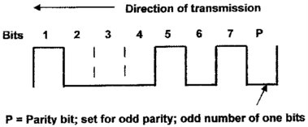](https://sites.google.com/site/mdprcp/Basic3-2B.tif?attredirects=0)

The following is an example of the ASCII code character ‘A’ with Start and Stop bits and the character parity checking bit (P). The parity feature can be set for either an odd or even number of total character one bits. The Start or Stop bit is not included when determining the character parity.

The following shows the ASCII code character ‘A’ without Start or Stop bits, which would be the character configuration when used in a Synchronous mode of operation. The character parity bit (P) may or may not be used. Also, the parity feature can be set for either an odd or even number of total character one bits. A synchronizing bit or character can be used depending on the send and receive devices and the data being transmitted. Example: An intermittent synchronizing character, framing every 4 – 6 characters, could be used when the data consist solely of characters; an intermittent synchronizing bit, framing every 16 bits, could be used when the data consists of miscellaneous information, not character oriented (patterns).

[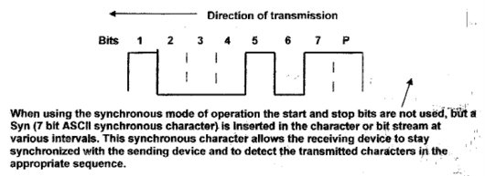](https://sites.google.com/site/mdprcp/Basic3-2D.tif?attredirects=0)

**DC Polar signals:**

Back to the early days; A DC ‘polar’ signal was often used for data transmission and instead of the signal just going to ‘0’ (ground) from a positive voltage (current), the polar signal goes to a negative voltage usually equal to the positive voltage. If a 12-volt signal was used the signal change for a ‘1’ bit to a ‘0’ bit would be from a +12-volt level to a –12 volt level. The advantage of using a polar signal is that less long-distance signal regeneration is required and signal distortion is less of a problem. Many polar operational circuits, especially in a local environment, used 12 and 24-volt levels because the circuits were usually short distance circuits.

These voltages gave a signal swing from +12 to –12 or +24 to –24, which compensated and allowed for a greater signal distortion level before the bits (pulses) became unreadable. The sending unit still generated non-polar DC pulses that changed from a 0 to a plus (+) voltage (current), which was then fed through the coils of a relay, and the polar signal, was generated by the relay contacts. In the early stages the relays were an electrical-mechanical unit with an in-line coil that activated mechanical contacts that in turn provided the polar signal on the connecting line. On the receiving end of the line the signal would be converted back to a non-polar signal by a relay mechanism. Figure 3-5 illustrates the use of a polar signal for the same character previously shown in Figure 3-4.

[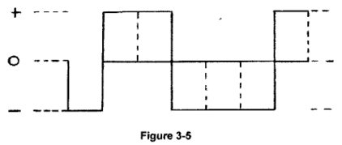](https://sites.google.com/site/mdprcp/Basic3-5.tif?attredirects=0)

**Distortion and Bias:**

Many factors cause signal distortion, such as: noise from motors, equipment / devices, extraneous signals picked up along the circuit, electrical interference (storms), circuit mileage (distance) and poor circuit connections or conditions. Two basic terms, distortion and bias (bit delay) are used to describe signal deterioration problems. The ‘hashed' part of Figure 3-6 illustrates how a distorted signal might appear if viewed on an oscilloscope. The uneven hashed line part represents the distorted signal (bits). Figure 3-7 Illustrates signal bias, which is position shifting of the DC pulses (bits). The broken lines show this pulse shift to the right of the original pulse position.

Usually the sending device that has a transmission-timing problem causes bias, but bias can also be caused by a series of in-line devices. Each line part, an electrical-mechanical relay, line length and quality, and other devices that are used to connect one line to another for extending the line (circuit) can cause bias. The Teletypewriter internal bias problems were usually caused by motor speed variations or malfunctioning clutch problems. Prior to sophisticated electronic devices Bias was corrected through adjustments to the transmitting device mechanism / electronics or through the use of an adjustable, manual or automatic, relay unit.

Most distortion correction devices are referred to as regeneration units that restore the signal to the original configuration. Either bias (bit shifting) or distortion if not corrected will reach the point where continuous errors will occur. Both distortion and bias can occur concurrently. Today the distortion problem still exists, but it is easily solved or corrected electronically.

[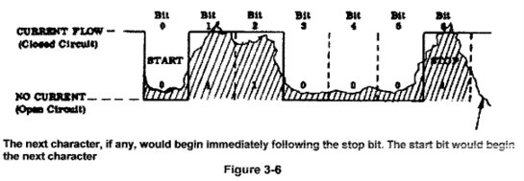](https://sites.google.com/site/mdprcp/basic3-6.tif?attredirects=0)

[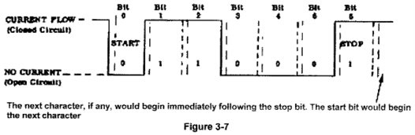](https://sites.google.com/site/mdprcp/Basic3-7.tif?attredirects=0)

**Noise:**

Another view of the effects of noise, distortion, and bias and other signal interference as the circuit distance grows is illustrated in figure 3-8. This is a 1970’s example, starting at the terminal position, of noise (distortion) problems along with signal degradation that could create data error problems. It becomes obvious that the noise (distortion) level could eventually become equal to the desired signal level. Since the 70’s signal regeneration, lines and equipment capabilities have greatly improved and signal distortion and degradation is much easier to control.

Prior to the invention of transistors, integrated logic and chips, which are used for automatic electronic distortion and bias regeneration functions, all DC pulse distortion problems were solved through the use of manually adjusted electrical mechanical relays. The distorted signal was fed through the relay winding (over simplified), which was sensitive to low voltages (current), lower than the original transmitted voltage, and the regenerated signal was fed from the contacts, which provided the proper level of voltage for the regenerated signal. The regenerated signal

would appear as illustrated in Figure 3-4 (make - break signal) or Figure 3-5 (polar signal).

[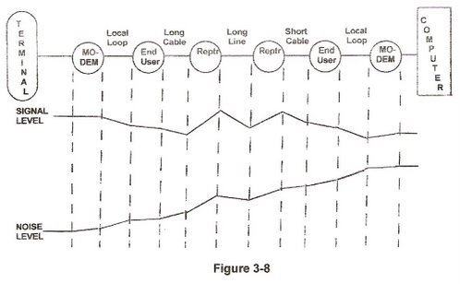](https://sites.google.com/site/mdprcp/basic3-8.jpg?attredirects=0)

**Analog Signals:**

An analog signal (AC) reverses polarity and current flow where a Direct Current (DC) signal maintains one polarity and current flows in only one direction. AC example below:

Analog signal polarity alternates between positive and negative current flow and accordingly the current flow reverses direction; the terms frequency, Hertz, wave, sine wave and wavelength are often used to describe AC signals:

[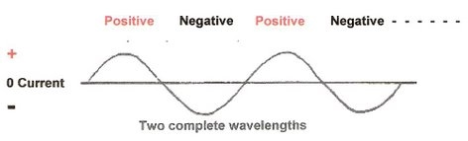](https://sites.google.com/site/mdprcp/basic3-8A.jpg?attredirects=0)

With the invention of the ‘Carrier’ in the late 1930s and then the MODEM (Modulator / Demodulator) in the 1960s data could be sent over the Telephone lines using Alternating Current (AC), referred to as Analog signals. DC signals are used locally on the DC side of the Carrier / MODEM and AC signals are used between the Carrier / MODEM on the telephone line. Alternating Current alternately reverses direction (polarity) at a rate based on the frequency of the generator,which could be a motor drivengenerator or an electronic generator (oscillator).

The Analog signals used for the telephone facilities and other electronic circuits are electronically generated because of the high frequencies used. The household AC current generated by an electrical mechanical generator is only 60 cycles, which means the current will reverse direction 60 times a second, from positive to negative or negative to positive, depending on what point the first cycle begins. An electrical mechanical generator is driven by an outside source, such as, a motor, hydroelectric (dams), steam (nuclear, coal, oil, natural gas) and wind. Compare this 60 cycles per second to a radio signal of 98 megacycles, which is a frequency of 98 million cycles per second. It would be difficult to generate that frequency with an electrical mechanical generator.

Below are examples of different frequency rates; the cycle width (one wave length) changes based on the frequency of the analog signal. The analog signal shown left is a higher frequency than the analog signal shown right.

[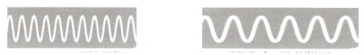](https://sites.google.com/site/mdprcp/Basic3-8B.tif?attredirects=0)

Figure 3-9 shows two terminals connected through a MODEM one on each end using DC signals from the terminal to the MODEM and analog signals between the MODEM(s). The widely used Telephone system facility (line) provides for a maximum frequency of 4000 Hz (Hertz), or in other terms a maximum analog signal of 4000 Hz (Hertz). Hertz replaced the cycles per second designation. When the telephone facility is used for a telephone (voice) conversation, or for any other purpose (data), the maximum frequency (bandwidth) available is 4000 Hz. In reality this frequency availability is reduced due to signal degradation.

The signal quality drastically drops below 300 Hz and above 3300 Hz, which provides a lower bandwidth, of about 3000-3300 Hz, for voice reproduction or data transfer. This bandwidth can be better utilized through the use of sophisticated equipment and additional conditioning of the lines. When the telephone facility is used for voice communications the facility (line and associated equipment) is the connection between the telephone hand set (microphone / mouthpiece) and the receiving handset (earpiece / speaker). In essence it is similar to speaking into a microphone connected to an amplifier, which then feeds the speakers, providing a reproduction of the spoken words.

The difference between the telephone facility and the amplifier would be the restriction in the usable frequency bandwidth and the quality of voice reproduction. A good amplifier would provide for a bandwidth of 1 cycle per second to above 20, 000 cycles per second. The broader bandwidth (low to high frequencies) will provide for much better reproduction of voice, instruments or music.

[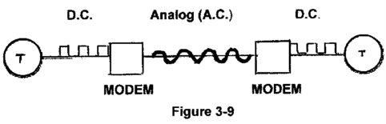](https://sites.google.com/site/mdprcp/basic3-9.tif?attredirects=0)

When a MODEM is connected to a telephone facility the MODEM or circuit provider must generate a carrier frequency in order to transmit data. This carrier frequency is similar to that required by radio or TV stations. When a person turns (tunes) a radio dial to, for example, 33 kilocycles (33 on the radio dial) the radio tunes in on a carrier frequency of 33,000 cycles per second. This frequency range is assigned to AM (Amplitude Modulation) stations. This is called the carrier frequency since it will be used to carry information. When a person speaks or music is played at the radio station the voice or music will modulate the carrier frequency creating highs and lows in the signal amplitude (amplitude modulation) based on the voice or music. This variable changing signal amplitude is deciphered at the radio receiver and the voice or music is reproduced. FM radio uses Frequency Modulation.

Note: A telephone voice (analog) facility is composed of a pair of wires; two pairs for full duplex operation using Carrier devices. But the full duplex MODEM can operate on a single pair of voice grade wires. A pair of wires is used for signal balancing, conditioning and impedance matching purposes. The connection in Figure 3-9 (previous page) would be configured using a pair of wires for the analog connection between the MODEM(s).

For this description of the MODEM using a telephone line only one carrier frequency will be considered. In the beginning only one MODEM (one on each end) was connected to a telephone line and the line served only the one circuit requirement. In order to convert the DC signals to an analog signal the MODEM (or telephone company) must provide a carrier frequency. This analog carrier signal is then modulated to represent the DC bit stream or analog signals. Modulation techniques are discussed in a little more detail in the carrier and MODEM pages, but for a basic description Figure 3-10 (two parts) provides a view of what would happen when the carrier (example: 1500 Hz) is modulated by another analog signal.

‘A’ is the base carrier frequency (Hz), ‘B’ is the input modulating signal, which could be an analog (voice) or DC bit pattern and ‘C’ is the amplitude modulated result. Figure 3-10 also illustrates, in the simplest form, what actually occurs in AM radio broadcasting. The carrier frequency (A) is a constant predetermined frequency that will be Amplitude Modulated (AM) by the transmitted analog voices or music (B). The modulating signal would be a variable analog or bit pattern signal under realistic conditions. Frequency Modulation and other modulation techniques are covered in the MODEM pages.

[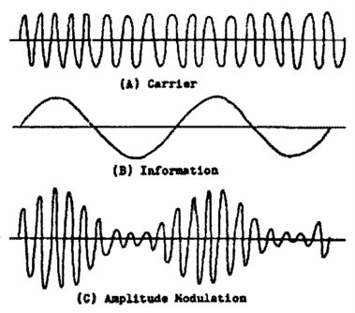](https://sites.google.com/site/mdprcp/basic3-9A.tif?attredirects=0)

[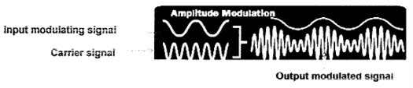](https://sites.google.com/site/mdprcp/basic3-9B.tif?attredirects=0)

**Figure 3-10**

**Voice Grade Channel:**

A 1970’s voice grade channel bandwidth of 4000 Hz is illustrated in Figure 3-11. This figure also shows the actual usable bandwidth (pass-band) of about 3000 - 3300 Hz that can be used with limited distortion or interference from outside sources. Over the years, since the 70’s, improvements in Voice Channel Conditioning, which compensates for signal degradation has increased the usability of the voice channel. Also, modulation techniques and MODEM capabilities have improved the ability to use the voice grade channel more efficiently and also increase the bit per second (bps) rate.

**The pass-band designation in Figure 3-11 identifies the usable frequency bandwidth available for undistorted usage, whether for voice or data transmission.**

**[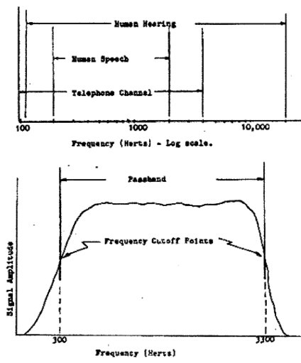](https://sites.google.com/site/mdprcp/basic3-11.tif?attredirects=0)**

**Figure 3-11**

Circuit (Line) configurations:

The functional terms series and parallel refer to transmission of data bits either serially, one after the other, or parallel where the bits are sent simultaneously on multiple lines (circuits). In serial operation the bits are always transmitted on the circuit one after the other, usually starting with bit zero (start) followed by bits one through five; then the stop bit (seven). Teletypewriters normally require a start and stop bit making a total of seven bits; shown in the example below, which also illustrates the clutch mechanism within a teletypewriter machine. The clutch is released by the start pulse and stopped by the stop pulse. The code illustrated below is the Baudot code. In today’s world all this activity would be accomplished electronically.

**[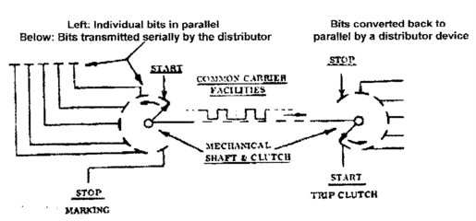](https://sites.google.com/site/mdprcp/basic3-11A.tif?attredirects=0)**

**[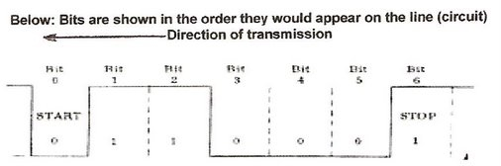](https://sites.google.com/site/mdprcp/basic3-11C.jpg?attredirects=0)**

A parallel operation requires a circuit (wire) for each bit. Parallel operation is primarily used within the confines of an office or computer system, normally for short distances using a cable.

‘Open’ or ‘closed’ circuit (line) operation describes a couple of types of circuits used from the 1850s up through the 1950s.

For example: The circuit below represents a ‘closed’ circuit because all the contacts at A, B and C are normally closed. This maintains the voltage on the circuit at all times when the circuit is not in use. Teletypewriters require a closed circuit, otherwise they would continue to run because the clutch would continually see a start bit (open / space bit). A send operation, which also creates a receive function, at either A, B or C could activate the circuit. K = Keyboard; P = Printer.

**[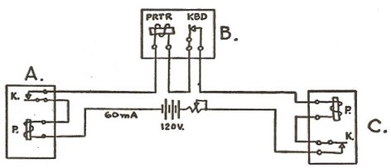](https://sites.google.com/site/mdprcp/PrtTel-4.jpg?attredirects=0)**

An ‘Open’ circuit refers to a circuit (line) that is continually in a state of no voltage (current) on the line when it is not being used. An operator would close the line (apply voltage) when they wanted to transmit or receive. This was normally accomplished through the use of a switch, which could be a part of the communication device or a separate switch.

Open circuit operation creates a problem if there is more than one user on the circuit. Any one of the operators could open the circuit (normal condition), which would lock out other users on the line (circuit). When there are multiple users on one circuit it becomes necessary to use a closed-circuit operation because no user is kept from using the connecting line(s) (circuits) during idle times.

A closed-circuit operation also allows operators or maintenance personnel to more easily identify problems on a circuit. Notice the slide switch on the Morse code Key, which was used to keep the circuit closed when the key was not in use.

**[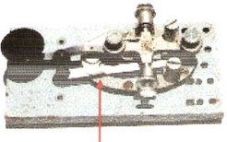](https://sites.google.com/site/mdprcp/3-11E.jpg?attredirects=0)**

The slide switch is shown in the closed position

Front End Computer:

The Front-End Computer and computers that functioned as Front Ends arrived in the 1960’s. A few reasons why a Front-End computer would be installed between a Data processor or Message processing computer would be as follows:

• Reduces the required main (host) computer memory storage, both primary and secondary memory. Also, the main computer software (programs) could be reduced in size. This was very important prior to the present normal 512 megabytes of memory and 60 gigabyte hard drives. In the 1960’s and early 70’s the data communication computer memory and drum/disc storage capacity was measured in kilobytes.

• Performs code set translation, which allows a variety of terminals to be used.

• Allow connections to variable speed terminal and lines, both asynchronous and synchronous.

• Handle characters, data bit streams and block by block data.

• Provide data buffers for the main processor.

• Perform protocol and signal control functions.

• Can be connected through a high speed computer port or controller

• Provide data error detection and correction functions

With the arrival of integrated circuits and the ‘chip’ a programmable terminal serving other terminals could provide front end functions for the connected terminals, which evolved into the present-day private user and Internet computer ‘Server’ network systems. A typical 1970s Front-End computer system serving a variety of terminals might appear as illustrated in Figure 3-12.

**[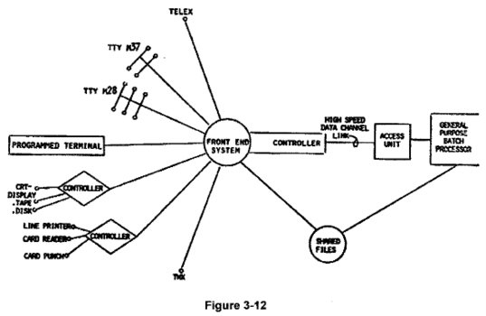](https://sites.google.com/site/mdprcp/basic3-12.tif?attredirects=0)**